Comparison of Capacitor Performance

DaVinci Labs
Technical Report #1

Alex
Rev. B, 2015-11-28

Table of Contents
Revision History 1
Abstract 2
Test Setup 2
Measurements 3
Screenshots 3
Capacitor #1, EEUFC1V102 : 1000 μF Electrolytic 3
Capacitor #2, EEUFC1C332: 3300 μF Electrolytic 4
Capacitor #3, EEUFR1A332B: 3300 μF Electrolytic 4
Capacitor #4, EEUFR1A682B: 6800 μF Electrolytic 5
Capacitor #5, EEUFC0J103S: 10000 μF Electrolytic 5
Capacitor #6, EECS0HD 224: 0.22 F GoldCap 6
Capacitor #7, EECF5R5U105: 1.0 F GoldCap 7
Capacitor #8, PA-5R0H474: 0.44 F PowerStor SuperCapacitors 7
Conclusion 8

Revision History
Date | Rev. | Author | Changes
2015-11-28 | A | Alex | Initial version, cap #1-#6
2015-11-28 | B | Alex | Added cap #7, #8, added weight of each capacitor
2015-12-01 | D | Alex | After review: moved elkos and small fixes

Abstract
The performance of eight capacitors is evaluated. Five capacitors are electrolytic capacitors, while the other three capacitors are SuperCapacitors:
- Panasonic EEUFC1V102, 1000 μF, 35 V, ESR 0.03 Ω (Reichelt RAD FC 1.000/35)
- Panasonic EEUFC1C332, 3300 μF, 16 V, ESR 0.02 Ω (Reichelt RAD FC 3.300/16)
- Panasonic EEUFR1A332B, 3300 μF, 10 V, ESR 0.018 Ω (Reichelt RAD FR 3.300/10)
- Panasonic EEUFR1A682B, 6800 μF, 10 V, ESR 0.012 Ω (Reichelt RAD FR 6.800/10)
- Panasonic EEUFC0J103S, 10000 μF, 6.3 V, ESR 0.02 Ω (Reichelt RAD FC10.000/6/3)
- Panasonic EECS0HD 224, 0.22 F, 5.5 V, ESR < 75 Ω (Reichelt SPK 220.000µF-V)
- Panasonic EECF5R5U105, 1.0 F, 5.5 V, ESR < 30 Ω (Reichelt SPK 1,0F)
- Cooper Bussmann PowerStor PA-5R0H474, 0.47 F, 5.0 V, ESR 0.2 Ω (Ebay)
The picture below shows the different capacitors, with #1 being on the left and #8 on the right hand side.

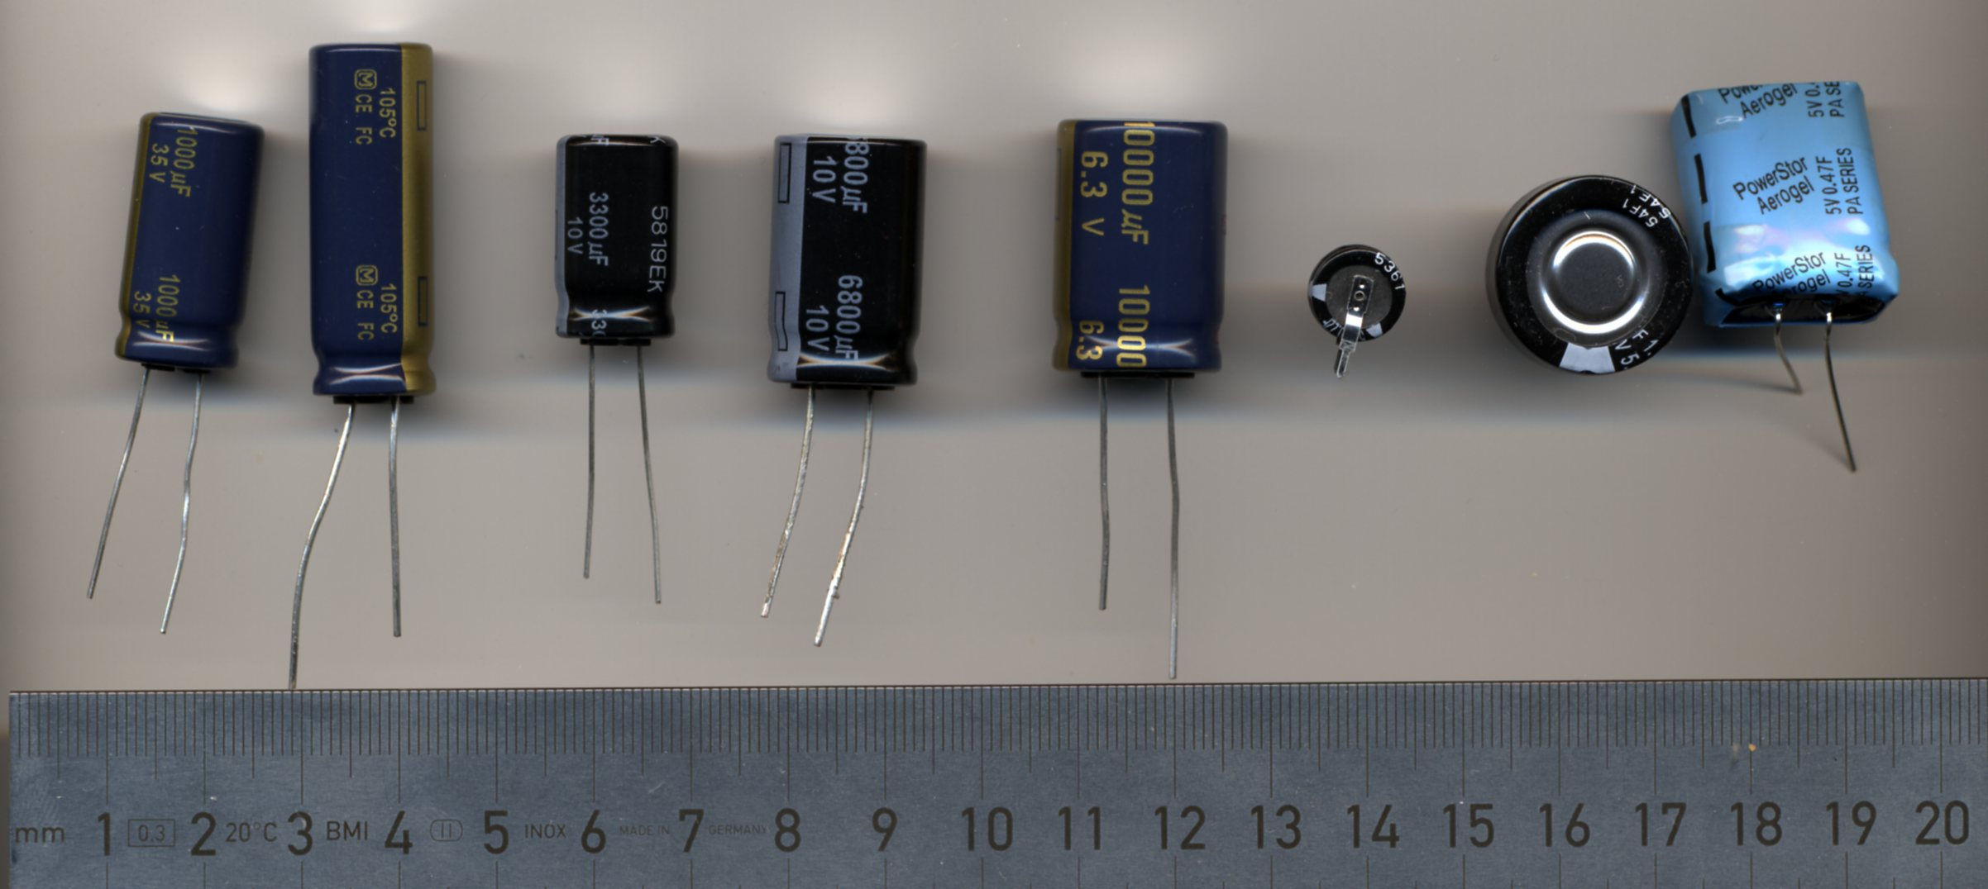

Test Setup
To simulate the power used in the DaVinciDriver, which draws up to 80 mA current, the capacitor is first charged with 5V, and then discharged through a resistive load of 55Ω, resulting in a current of ≈100 mA.
Measurements are taken with an AnalogDiscovery PC-based oscilloscope from Digilent Inc.

Measurements
Table 1 summarizes the measurement results.
# | Capacitor | Nickname | Capacity | ESR | Discharge Time to 3.3V | Weight
1 | EEUFC1V102 |  | 1000 μF | 0.03 Ω | 0.026 s | 6 g
2 | EEUFC1C332 |  | 3300 μF | 0.02 Ω | 0.092 s | 8 g
3 | EEUFR1A332B |  | 3300 μF | 0.018 Ω | 0.092 s | 4 g
4 | EEUFR1A682B |  | 6800 μF | 0.012 Ω | 0.1907 s | 8 g
5 | EEUFC0J103S |  | 10000 μF | 0.02 Ω | 0.3015 s | 10 g
6 | EECS0HD 224 | Old small GoldCap | 0.22 F | < 75 Ω | 0.005 s | 1 g
7 | EECF5R5U105 | Old big GoldCap | 1.0 F | < 30 Ω | 7.601 s | 8 g
8 | PA-5R0H474 | New blue SuperCap | 0.47 F | 0.2 Ω | 13.282 s | 4 g

Screenshots
The following screenshots show the discharge curves of the capacitors. Please note that the x-axes have different scales in order to show all relevant data.

Capacitor #1, EEUFC1V102 : 1000 μF Electrolytic
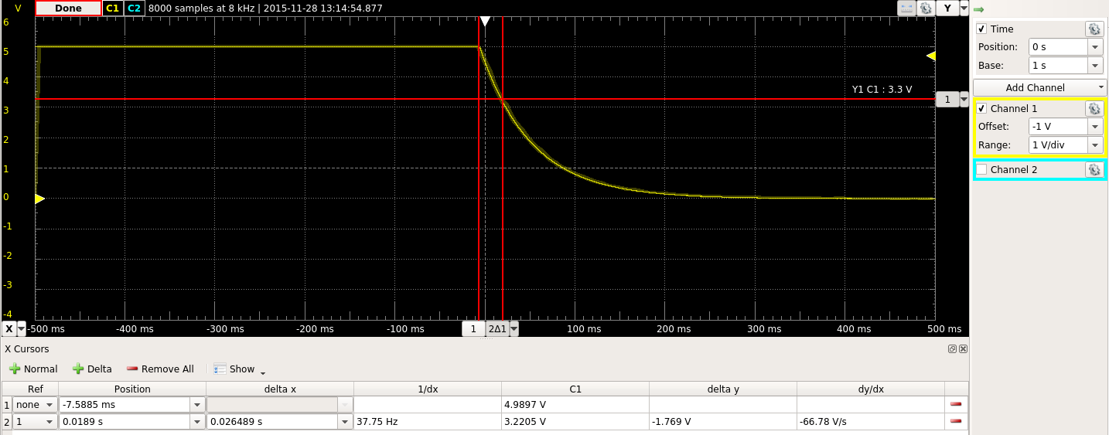
Discharge time of 0.026 s with a very low ESR. Good performance, but too low capacity for our purposes.

Capacitor #2, EEUFC1C332: 3300 μF Electrolytic
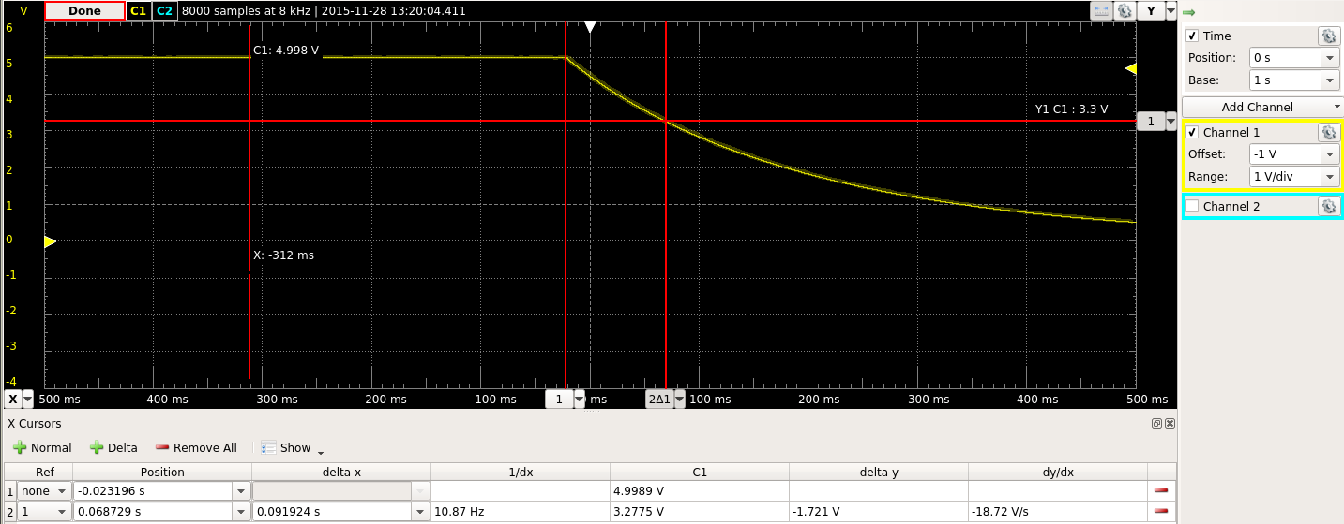
Discharge time of 0.092 s and low ESR. Same good performance as the smaller electrolytic capacitor #1 with 3x capacity. Still too little capacity for our purposes.

Capacitor #3, EEUFR1A332B: 3300 μF Electrolytic
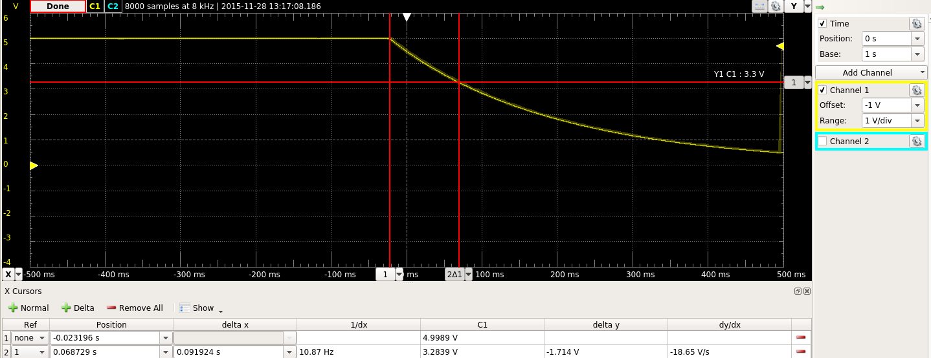
Essentially the same performance as the previous capacitor, #2, with a nearly identical datasheet. However, this capacitor only has half the physical size of capacitor#2.

Capacitor #4, EEUFR1A682B: 6800 μF Electrolytic
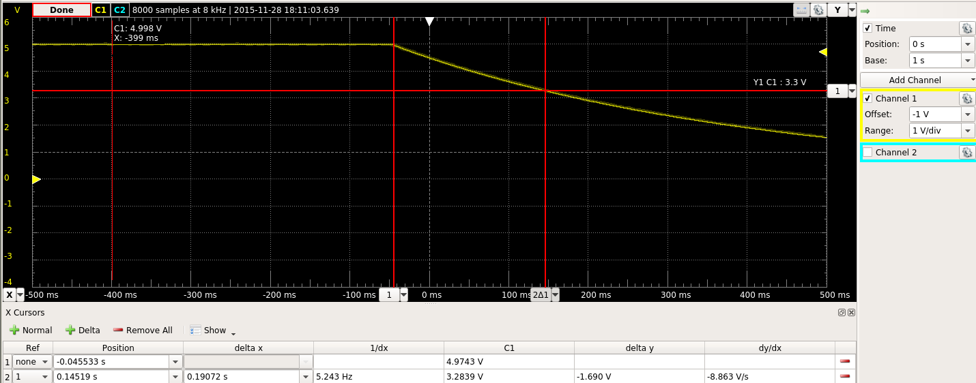
Standard electrolytic capacitor similar to #1-#3. Its bigger capacity extends the holdover time to 0.19 s, which is still not enough for our purposes.

Capacitor #5, EEUFC0J103S: 10000 μF Electrolytic
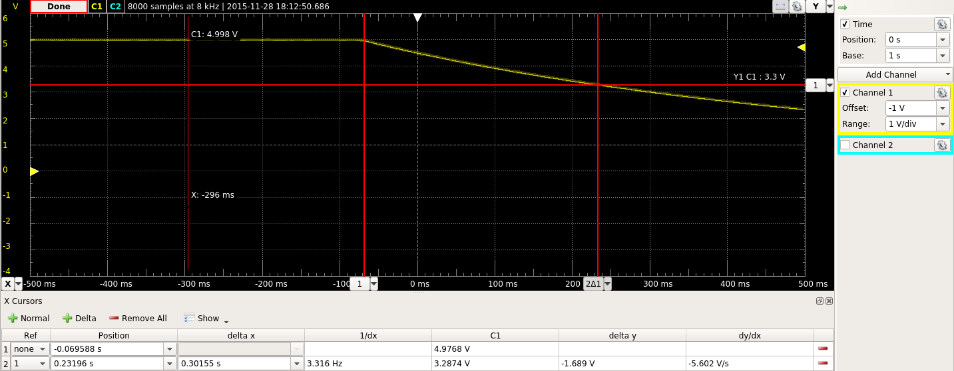
The highest capacity capacitor with 10000 μF and an expected holdover time of 0.3 s. Not enough, especially considering the weight of this capacitor.

Capacitor #6, EECS0HD 224: 0.22 F GoldCap
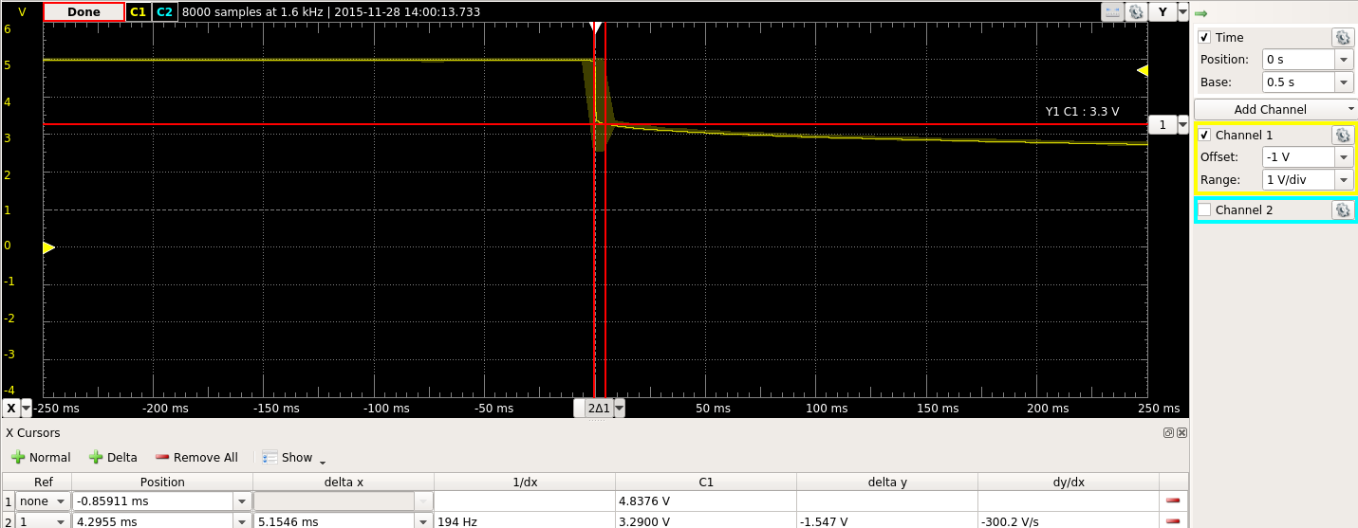
This is the first capacitor we bought, exhibiting a initial voltage drop of nearly 1.7 V down to 3.3 V which is the minimum acceptable limit. This is caused by a very high ESR value. It is by far the smallest capacitor and according to the data sheet more applicable to backup memory and real-time clocks. It is not intended for milliampere usage scenarios.

Capacitor #7, EECF5R5U105: 1.0 F GoldCap
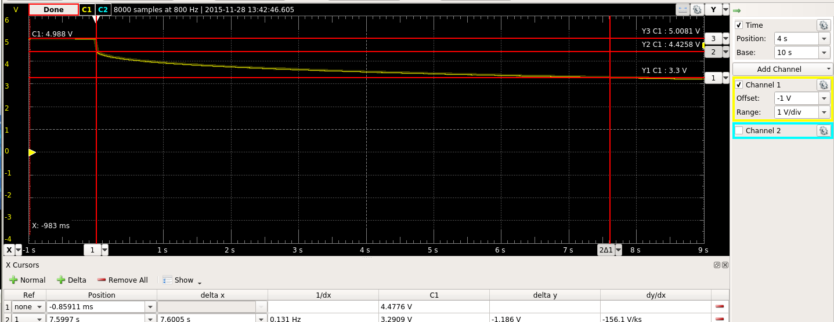
A much bigger capacitor in physical size than #6 and with 4x its capacity, this capacitor performs better due to its lower ESR value. Compared to the other capacitors the ESR value is still too high and clearly visible in the screenshot above: a step of 0.8 V. Total time to support our car's circuit is acceptable with more than 7 seconds hold-over time.

Capacitor #8, PA-5R0H474: 0.44 F PowerStor SuperCapacitors
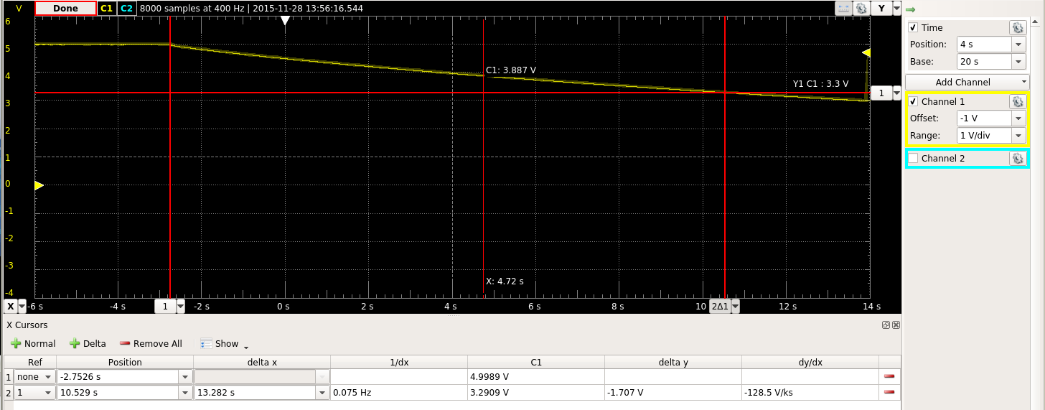
This capacitor combines the low ESR of the ordinary electrolytic capacitors #1-#5 with the high capacity of the GoldCaps, resulting in an extraordinary holdover time of over 13 seconds. A very good performance considering a price under 1 €, less than the price of the 1.0 F GoldCap #7 which costs 1.60 €.

Conclusion
Capacitor #8 clearly stands out in this comparison. Longest holdover time at a good price and low weight. The only drawback is its physical size of 24x20x10 mm³.

